British International School of Ljubljana

History, year 7/8

HITLER DESTROYS

THE TREATY OF VERSAILLES

IN FIVE EASY STEPS

1. 1936 Remilitarization of the Rhineland
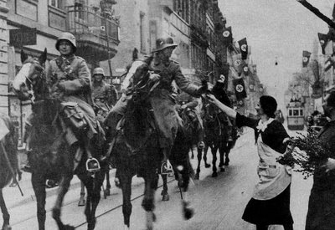
Under the Versailles Settlement, the Rhineland was demilitarized. Germany accepted this arrangement under the Locarno Treaties of 1925. Hitler claimed that it threatened Germany and on 7 March 1936 he sent German forces into the Rhineland. He gambled on Britain not getting involved but was unsure how France would react. The action was opposed by many of his advisers. His officers had orders to withdraw if they met French resistance. France consulted Britain and lodged protests with the League, but took no action. Prime Minister Stanley Baldwin said that Britain lacked the forces to back its guarantees to France and that public opinion would not allow it. In Britain it was thought that the Germans were merely walking into “their own back yard”. Hugh Dalton, a Labour Party MP who usually advocated stiff resistance to Germany, said that neither the British people nor Labour would support military or economic sanctions.[ In the Council of the League, only the Soviet Union proposed sanctions against Germany. Hitler was invited to negotiate. He proposed a non-aggression pact with the Western powers. When asked for details he did not reply. Hitler's occupation of the Rhineland had persuaded him that the international community would not resist him and put Germany in a powerful strategic position.
In 1937 Stanley Baldwin resigned as British Prime Minister and Neville Chamberlain took over. Chamberlain pursued a policy of appeasement and rearmament. Chamberlain's reputation for appeasement rests in large measure on his negotiations with Hitler over Czechoslovakia in 1938.

2. The Anschluss 1938
When the German and Austro-Hungarian empires were broken up in 1918, the victors vetoed the inclusion of Austria within a German state, but many German-speaking Austrians wished to join Germany in the realignment of Europe. The constitutions of both the Weimar Republic and the First Austrian Republic included the aim of unification, which was supported by democratic parties. However, the rise of Hitler dampened the enthusiasm of the Austrian government for such a plan. Hitler had promoted a pan-German Reich from the beginning of his career and stated in Mein Kampf (1924) that he would attempt a union with Austria, by force if necessary. By early 1938, Hitler had consolidated his power in Germany and was ready to implement this long-held plan.
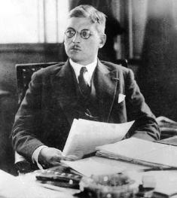
The Austrian Chancellor Kurt Schuschnigg (below) wished to pursue ties with Italy, but turned to Czechoslovakia, Yugoslavia and Romania (the Little Entente). To this Hitler took violent exception. In January 1938 the Austrian Nazis attempted a putsch, following which some were imprisoned. Hitler summoned Schuschnigg to Berchtesgaden in February and demanded, with the threat of military action, that he release imprisoned Austrian Nazis and allow them to participate in the government. Schuschnigg complied and appointed Arthur Seyss-Inquart, a pro-Nazi lawyer, as interior minister. To forestall Hitler and to preserve Austria's independence, Schuschnigg scheduled a plebiscite on the issue for 13 March. Hitler demanded that the plebiscite be canceled. The German ministry of propaganda issued press reports that riots had broken out in Austria and that large parts of the Austrian population were calling for German troops to restore order. On 11 March, Hitler sent an ultimatum to Schuschnigg, demanding that he hand over all power to the Austrian Nazis or face an invasion. The British Ambassador in Berlin registered a protest with the German Government against the use of coercion against Austria. Schuschnigg, realizing that neither France nor the United Kingdom would actively support him, resigned in favour of Seyss-Inquart, who then appealed to German troops to restore order. On 12 March the 8th Army of the German Wehrmacht crossed the Austrian border. They met no resistance and were greeted by cheering Austrians. This invasion was the first major test of the Wehrmacht's machinery. Austria became the German province of Ostmark, with Seyss-Inquart as governor. A plebiscite was held on 10 April and officially recorded a support of 99.73 percent of the voters.[
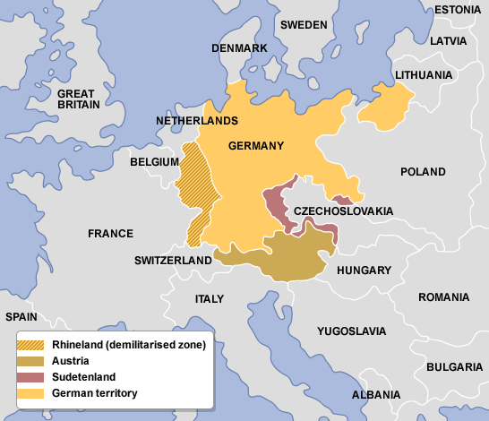
Although the victorious Allies of World War I had prohibited the union of Austria and Germany, their reaction to the Anschluss was mild.[ Even the strongest voices against annexation, particularly those of Fascist Italy, France and Britain (the “Stresa Front“) were not backed by force. In the House of Commons Chamberlain said that “The hard fact is that nothing could have arrested what has actually happened [in Austria] unless this country and other countries had been prepared to use force.”[ The American reaction was similar. The international reaction to the events of 12 March 1938 led Hitler to conclude that he could use even more aggressive tactics in his plan to expand the Third Reich. The Anschluss paved the way for Munich in September 1938 because it indicated the likely non-response of Britain and France to future German aggression. Again, it must be remembered that the whole world was knee-deep in economic depression at this time, and the allies of World War I were in no condition to advance militarily on anyone. Across the Atlantic, the United States had its own economic woes, not the least of which was mass unempl oyment. Further, and perhaps most important, Americans were in no mood to go to war again over European “squabbles” over boundaries or ethnic governments.

3. Sudetenland 1938
Under the Versailles Settlement, Czechoslovakia was created, including the Sudetenland, which had a majority German population. In April 1938, Sudeten Nazis, led by Konrad Henlein, agitated for autonomy. Chamberlain, faced with the danger of a German invasion, warned Hitler that Britain might intervene. Hitler ordered an attack on Czechoslovakia. Lord Runciman was sent by Chamberlain to mediate in Prague and persuaded the Czech government to grant the Sudeten virtual autonomy. Henlein broke off negotiations and Hitler railed against Prague.[
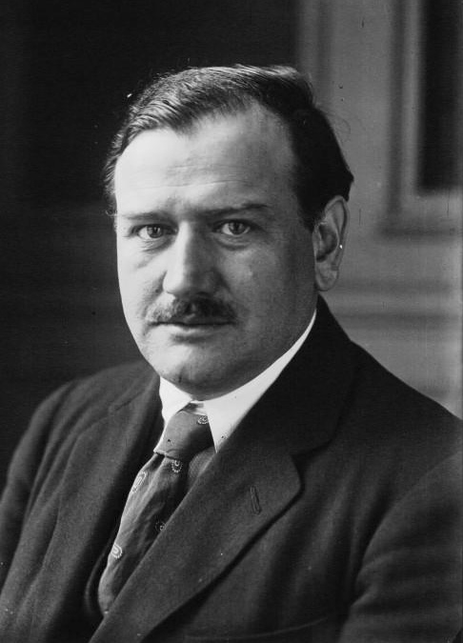
In September, Chamberlain flew to Berchtesgaden to negotiate directly with Hitler, hoping to avoid war. Hitler now demanded that the Sudetenland should be absorbed into Germany, convincing Chamberlain that refusal meant war. Chamberlain, with France, told the Czech president that he must hand to Germany all territory with a German majority. Czechoslovakia would thus lose 800,000 citizens, much of its industry and its mountain defences in the west. In effect, the British and French pressed their ally to cede territory to a hostile neighbour to prevent annihilation.
Hitler then informed Chamberlain that Germany was about to occupy the Sudetenland and that the Czechoslovaks had to move out. The Czechoslovaks rejected the demand, as did the British and the French. Mussolini persuaded Hitler to put the dispute to a four-power conference. Czechoslovakia was not to be a party to these talks. On 29 September, Hitler, Chamberlain, Édouard Daladier (the French Prime Minister, above) and Mussolini met in Munich. They agreed that Germany would complete its occupation of the Sudetenland, but an international commission would consider other disputed areas. Czechoslovakia was told that if it did not submit, it would stand alone. At Chamberlain's request, Hitler signed a peace treaty between the United Kingdom and Germany. Chamberlain returned to Britain promising “peace for our time“.
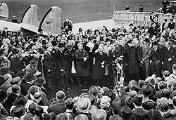
The photo show Chamberlain landing at Heston aerodrome on 30 September 1938 after his meeting with Hitler at Munich. In his hand he holds the peace agreement between Britain and Germany. He is extremely pleased with himself, and is waving the famous piece of paper in the air in triumph.
Bloody idiot.

4. Czechoslovakia 1939
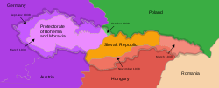
In March 1939, Chamberlain foresaw a possible disarmament conference between himself, Daladier, Hitler, Mussolini and Joseph Stalin; his home secretary, Samuel Hoare, said, “These five men, working together in Europe and blessed in their efforts by the President of the United States of America, might make themselves eternal benefactors of the human race.”[ That month, Czechoslovakia ceased to exist, divided among Germany, Hungary, Poland, and an independent Slovakia.

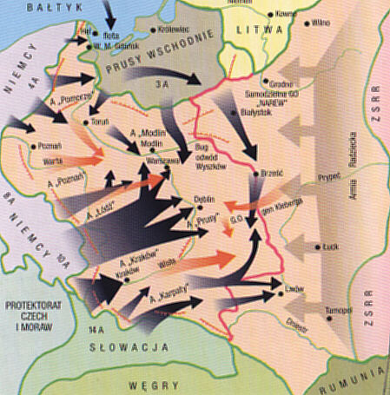
5. Poland
The failure of Munich precipitated a shift in policy and Chamberlain set in place preparations for war, including an expansion of civil defence.[ In March 1939 Chamberlain assured the Poles that Britain would support them if their independence was threatened. In April, Hitler began to make demands on the free city of Danzig (now Gdansk). Britain's assurance to Poland became a formal treaty in August, but the Foreign Secretary Lord Halifax urged the Poles to negotiate with Hitler[ and pressed them to give up Danzig.[ On 1 September Hitler invaded Poland and on 3 September Britain declared war on Germany. In October, Chamberlain rejected Hitler's offer of peace.
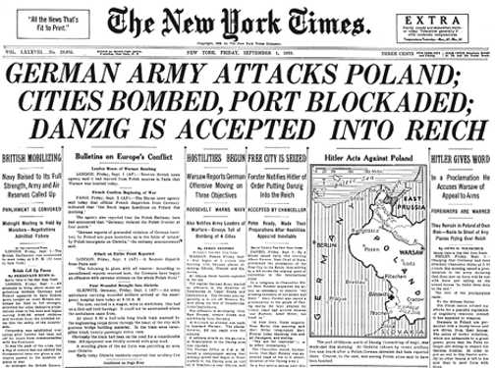
Chamberlain's conduct of the war was not popular and on 10th May 1940 Winston Churchill became Prime Minister. In July, some politicians inside and outside the government were still willing to consider Hitler's peace offer, but Churchill would not. Chamberlain died on 9 November the same year. Churchill delivered a tribute to him in which he said, “Whatever else history may or may not say about these terrible, tremendous years, we can be sure that Neville Chamberlain acted with perfect sincerity according to his lights and strove to the utmost of his capacity and authority, which were powerful, to save the world from the awful, devastating struggle in which we are now engaged.”

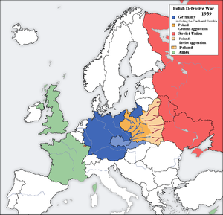
Meanwhile, Hitler had overthrown the Versailles settlement in a few years; a few years more, and he ruled almost all of Europe – see the map below.

Was appeasement a good idea?

RJCM

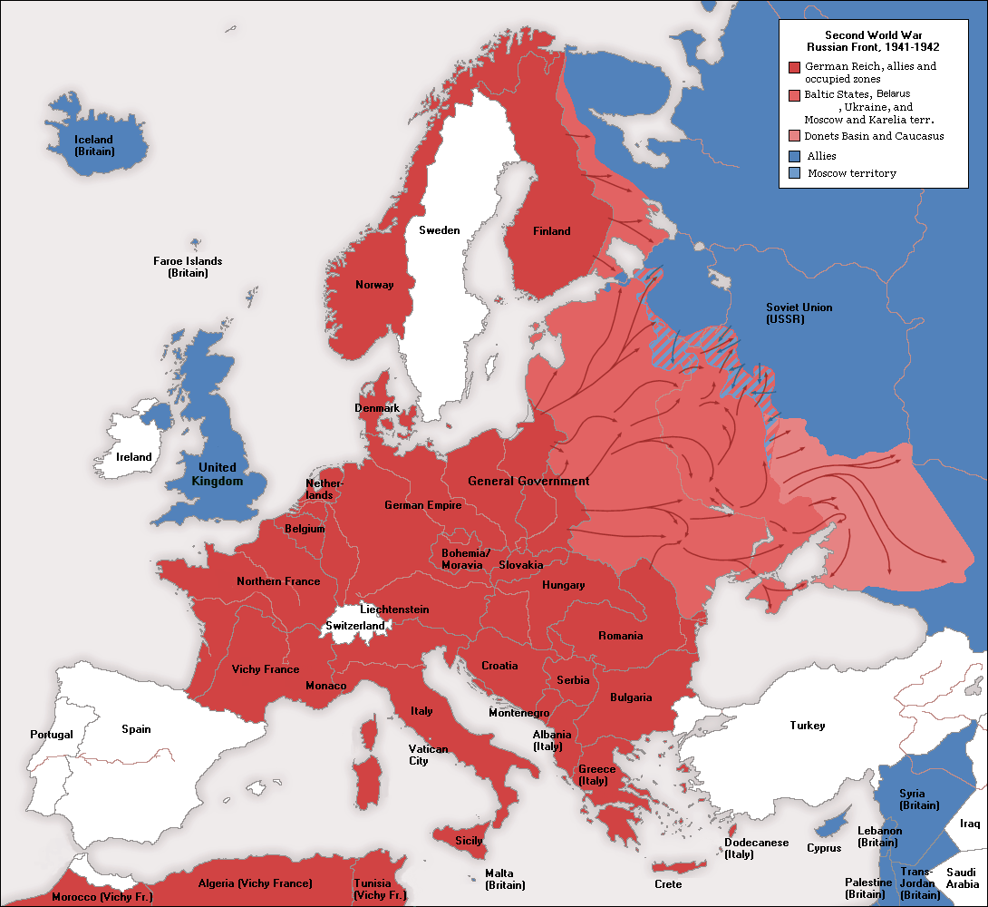
25 January 2012

